**Weekly report 5**

**Group 14: Learners.**

Members:

1. Varun Parekh - AU2040011
2. Vanshit Shah - AU2040098
3. Madhvendra Jhala - AU2040162
4. Ushmay Patel - AU2040253

We tried to understand the reasoning behind the parameters and why they are the optimum ones.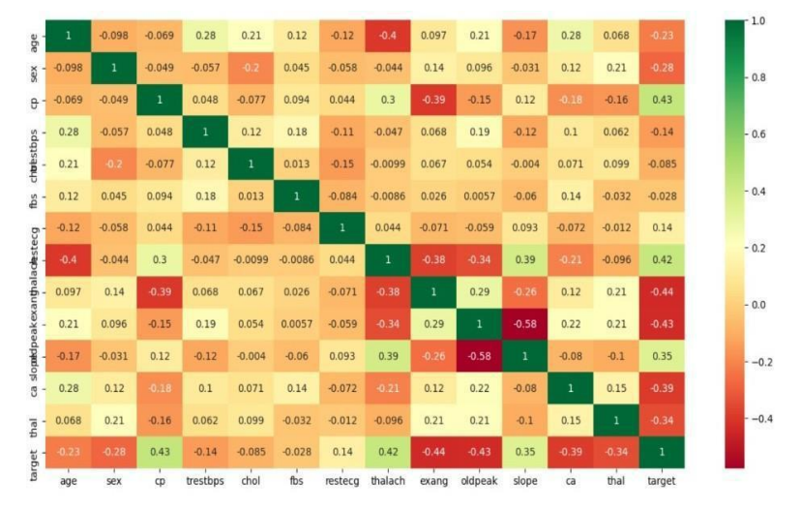

The prior probabilities of various classes and the probability of various attributes for each class are the parameters that are learned in Naive Bayes. In the test phase, the probability of each class for the provided sample is estimated using the learned parameters.

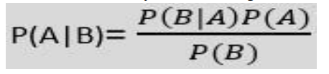

* P(A|B) is Posterior probability:Probability of hypothesis A on the observed event B.
* P(B|A) is Likelihood probability: Probability of the evidence given that the probability of a hypothesis is true.
* P(A) is Prior Probability: Probability of hypothesis before observing the evidence.
* P(B) is Marginal Probability: Probability of Evidence.

We also tried to understand the drawbacks of logistic regression on our data set.

There are many other data sets and receiving an accuracy of 74-75% or even 80% is not sufficient, when it is a medical problem, especially a heart prediction problem. So we are trying to find the best classifiers among which we can touch prediction of more than 95%

Also, other guidelines given by the sir are also kept in mind, and we are trying to cover every single aspect of it.

With references and reading material we feel that XGBOOST can perfectly fit in our model. So now we are looking forward to understanding how it works.